# Operational Concept Description (OCD)

**Fuppy**

**Team 07**

Krupa Patel (Product Manager)

Adil Assouab (Requirement Engineer)

Yiyuan Chen (Software Architecture)

Praveen Chander (Design/Prototype)

Zhouyun Feng (Developer)

Fereshteh Khorzani (Quality Focal Point)

**<11/30/2016>**

# 

# Version History

|  |  |  |  |  |
| --- | --- | --- | --- | --- |
| **Date** | **Author** | **Version** | **Changes made** | **Rationale** |
| 08/20/05 | PP | 1.0 | * Original template for use with LeanMBASE v1.0 | * Initial draft for use with LeanMBASE v1.0 |
| 08/28/05 | PP | 1.1 | * Added section 3.2 | * Section 3.2 was added to provide traceability for the outcome in the Benefits Chain |
| 08/30/06 | SK, RT | 1.6 | * Added Template for Tables and Figures | * Consistent format |
| 10/04/06 | SK | 1.61 | * Added section 3.3.1 | * Section 3.3.4 |
| 09/14/07 | SK | 1.9 | * Updated Section 2.4, 3.3.1, 3.3.2, 3.3.3 | * Consistent with LeanMBASE V1.9 |
| 08/25/08 | PA | 2.0 | * Swapped sections 3.4 and 3.5. * Renamed section 2.4 title from “Benefits Chain (Initiatives, Expected Outcomes, and Assumptions)” to “Benefits Chain” * Replaced References section (1.2) with “Status of the OCD” * Edited Table 1 structure to be consistent with the Instructional ICM-Sw OCD Guideline. * Added Figure 2, Figure 3, and Figure 4 * Edited Table 2 to be consistent with the Instructional ICM-Sw OCD Guideline | * Initial draft for use with Instructional ICM-Sw v2.0 modified from LeanMBASE v1.9 |
| 05/22/09 | SK | 2.1 | * Embedded description in each Table * Removed section 3.5 Prototype * Moved all goals to the Section 3.1 * Removed Section 4. WikiWinWin Result * Added Section 3.1.4 Constraints * Added Section 3.1 Current System | * To be consistent with ICM EPG template set standard V2.1 * To leanify and rearrange data presentation * Moved Prototype information to Prototype report * To document information about current system |
| 08/15/12 | TK | 2.2 | * Added Program Model * Updated index of subsections in section 2 Shared Vision | * To be consistent with ICSM EPG |

# Table of Contents

Operational Concept Description (OCD)

Version History

Table of Contents

Table of Tables

Table of Figures

Introduction

Purpose of the OCD

Status of the OCD

Shared Vision

Benefits Chain

System Capability Description

2.3 System Boundary and Environment

System Transformation

Information on Current System

Infrastructure

Artifacts

Current Business Workflow

System Objectives, Constraints and Priorities

Capability Goals

Level of Service Goals

Organizational Goals

Constraints

Relation to Current System

Proposed New Operational Concept

Element Relationship Diagram

Business Workflows

Organizational and Operational Implications

Organizational Transformations

Operational Transformations

# Table of Tables

*Table 1: The Program Model*

*Table 2: Level of Service Goals*

*Table 3: Relation to Current System*

# Table of Figures

*Figure 1: Benefits Chain Diagram of Fuppy*

*Figure 2: System Boundary and Environment Diagram of Fuppy*

*Figure 3:Activity Diagram - Working of current system*

*Figure 4:* *Element Relationship Diagram of Fuppy pet adoption user Mobile Application (NDI-intensive project)*

*Figure 5: Element Relationship Diagram*

*Figure 6: Business Workflow Diagram of Fuppy*

### Introduction

#### Purpose of the OCD

This document provides, in detail, the shared visions and goals of the stakeholders of the Fuppy pet adoption and fostering system. The success-critical stakeholders of the project are Adam Schechter, as the project owner; local pet adopters and animal shelters as users.

#### Status of the OCD

The status of the OCD is currently at the initial version in the development phase. The scope of the Fuppy project is limited to address the main risks identified in the exploration phase.

### Shared Vision

**Table 1: The Program Model**

|  |  |  |  |
| --- | --- | --- | --- |
| **Assumptions**  User wants to adopt pets  There are agencies who have pets for adoption/foster  Users are ready to user mobile application  We have data of pets | | | |
| **Stakeholders** (Who is accountable for the initiatives) | **Initiatives**  (What to do to realize benefits) | **Value Propositions**  (Benefits i.e Why) | **Beneficiaries**  (Who derives value) |
| * Client * Developer * User * Shelter | * Develop Mobile application * Market the App * Calculate the success rate | * Decrease death of animals * Increase awareness of sheltered animals * Improve the search for adoptable pets * Increase user to adopt from adoption agencies * Increase the probability of finding a match | * Shelters * Users |

**Legend:**

Initiatives that need to be undertaken to help beneficiaries **derive value** from the expected benefits/value propositions

Initiatives that need to be undertaken to help **deliver value** to the beneficiaries (i.e. “how” will the benefits reach the beneficiaries?)

#### benefit chain.pngBenefits Chain

Client promotes

**Figure 1: Benefits Chain Diagram of Fuppy**

#### System Capability Description

The part of the Fuppy module to be developed is the mobile application for users to adopt a pet animal. The main aim of this project is to portray Fuppy in a new foreground and provide easy access with better user experience through a mobile platform.

The mobile application is open only to the users side of the market who are looking for a medium to adopt a pet . The application focuses only on registered users of age group 18 and above. The main modules of the application are authentication, search engine system and appointment system.

The first function comprises the authentication system which provides all the content regarding the animals for adoption and the shelter information only to users registered in the system. If a guest wishes to access the above, he must go through the registration portal initially.

The second function comprises an elaborate search engine with location based filter services.

The third function is to provide the users who are interested in a particular animal, a way to book an appointment to the shelters from which they wish to adopt.

#### System Boundary and Environment

Pet Finder

 **Figure 2: System Boundary and Environment Diagram-of Fuppy**

### System Transformation

#### Information on Current System

##### Infrastructure

The current system comprises of a web application that portrays a foreground for both user and shelter. A location based search filter is provided for any end user to search for the information regarding the animals provided by the shelters. There exists a registration system that restricts the end user to adopt any pet from shelter until they become a registered adopter of fuppy. Since this is a two sided market, the users also have the privilege to post a pet for adoption at this time the user becomes a shelter for the pets he/she has for adoption.

The web application is supported with a Java backend that establishes the connectivity and REST routing with the database maintained in the Amazon Web Server(AWS). Initially the database is populated with the data fetched from Petfinder organization using an API.

##### Artifacts

|  |  |
| --- | --- |
| A-01 Petfinder API : | The interface that fetches information regarding the pets from the adoption agencies. |
| A-02 AWS : | The web servers that has the database filled with data regarding both the adoption agencies and the adopters. |

##### Current Business Workflow

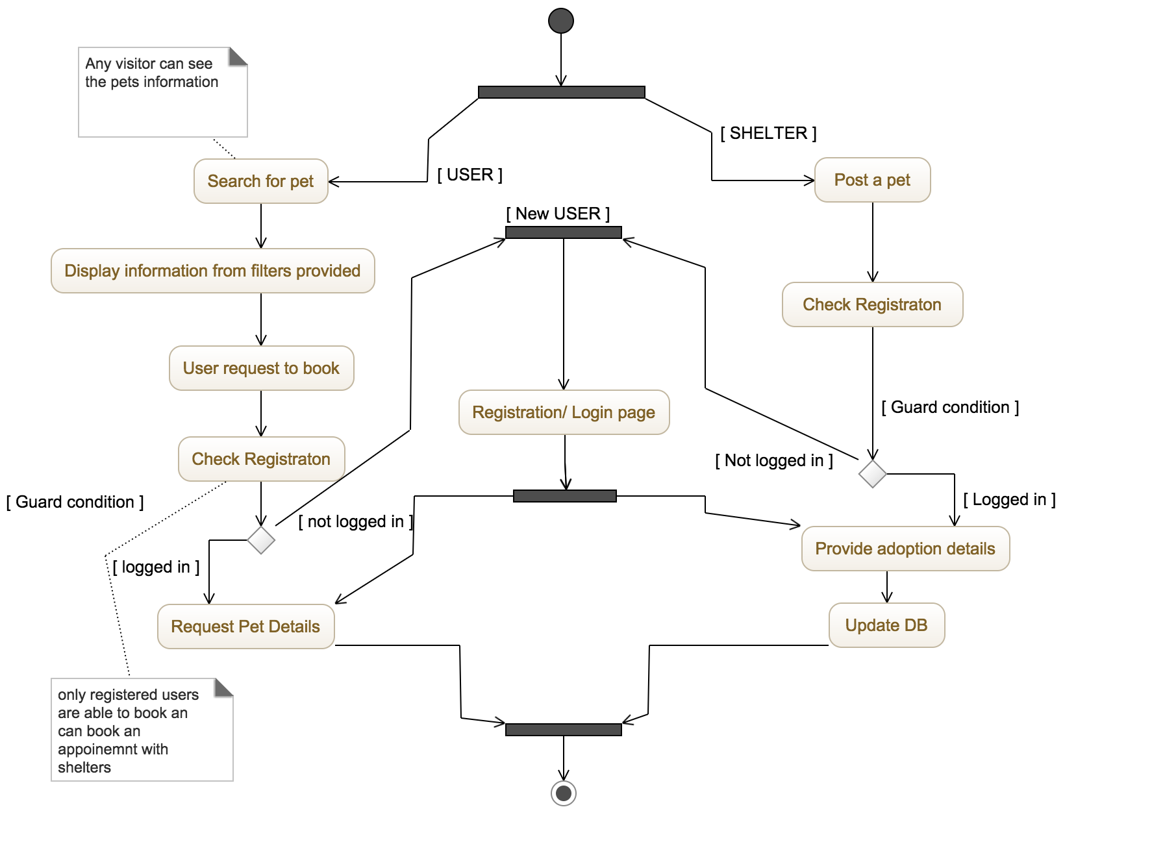

**Figure 5: Activity diagram - Working of current system**

#### System Objectives, Constraints and Priorities

##### Capability Goals

**Table 1: Capability Goals**

|  |  |
| --- | --- |
| Capability Goals | Priority |
| OC-1 Registration: Only registered users can access the credentials | Must have |
| OC-2 Filter based search: Users have control of search filters | Must have |
| OC-3 User shelter conversion: User can post a pet for adoption | Optional |
| OC-4 Google maps Integration:Live map display for selection | Moderate |

##### Level of Service Goals

**Table 2: Level of Service Goals**

|  |  |  |
| --- | --- | --- |
| **Level of Service Goals** | **Priority Level** | **Referred WinWin Agreements** |
| **Usability**: Content display should take minimalistic time and should follow UX/UI concepts to have better readability to users | High | **Win Condition** (**WC_4055**):  media |
| **Scalability:** A new front end of Native android mobile application is provided in addition with the existing web application | High | **Win Condition** (**WC_4009**):  search system |
| **Availability**: Information Center: Provide detailed description of the pets to users | High | **Win Condition** (**WC_4063**):  appointment system |
| **Appointment**: Live notification of appointments by users to shelters should be available | Medium | **Win Condition** (**WC_4008**):  appointment system |
| **Database Integrity**: Pet’s information should be universally available for remote access | Low | **Win Condition (WC_4052):**  **search system** |

##### Organizational Goals

**OG-1:** Make adoption of animals easier by providing easy access mobile application

**OG-2:** Promote adoption directly from adoption shelters and fosters cares and reduce euthanization of animals

**OG-3:** Provide more choices for adoption and expansion of animal health care.

##### Constraints

**CO-1: Android compatibility:** The new application must be compatible with the older and lower versions of android platforms

**CO-2: Zero Monetary Budget:** The selected NDI/NCS should be free or no monetary cost.

**CO-3: Java as a Development Language**: Java will be used as a development language.

##### Relation to Current System

**Table 3: Relation to Current System**

|  |  |  |
| --- | --- | --- |
| **Capabilities** | **Current System** | **New System** |
| Roles and Responsibilities | Web application for the users to adopt pets and shelters to add detailed regarding foster animals | New Android mobile application for the User side to adopt pets |
| User Interactions | Live Map user interaction enabling location based filters for selections | Users can access the information regarding the animals and make appointments to shelters |
| Infrastructure | Web Application - AWS server interaction. Custom Database maintenance | Mobile UI -Petfinder integration |
| Stakeholder Essentials and Amenities | All updation of the shelter details must be fetched periodically | Users must have location based access and advanced filter options. |
| Future Capabilities | To sustain and maintain a system without the data from Petfinder | Expand the mobile application to the shelter module |

#### Proposed New Operational Concept

##### Element Relationship Diagram

Untitled Diagram.png

**Figure 6: Element Relationship Diagram of Fuppy pet adoption User Mobile application   
(NDI-intensive project)**

On Figure 6, the Element Relationship diagram shows the relationship between the users, the mobile application and how the data is being fetched from the external sources. API integration with the Petfinder has been successfully made to fetch the data but challenges are being faced to implement all the location based search filters.

##### Business Workflows

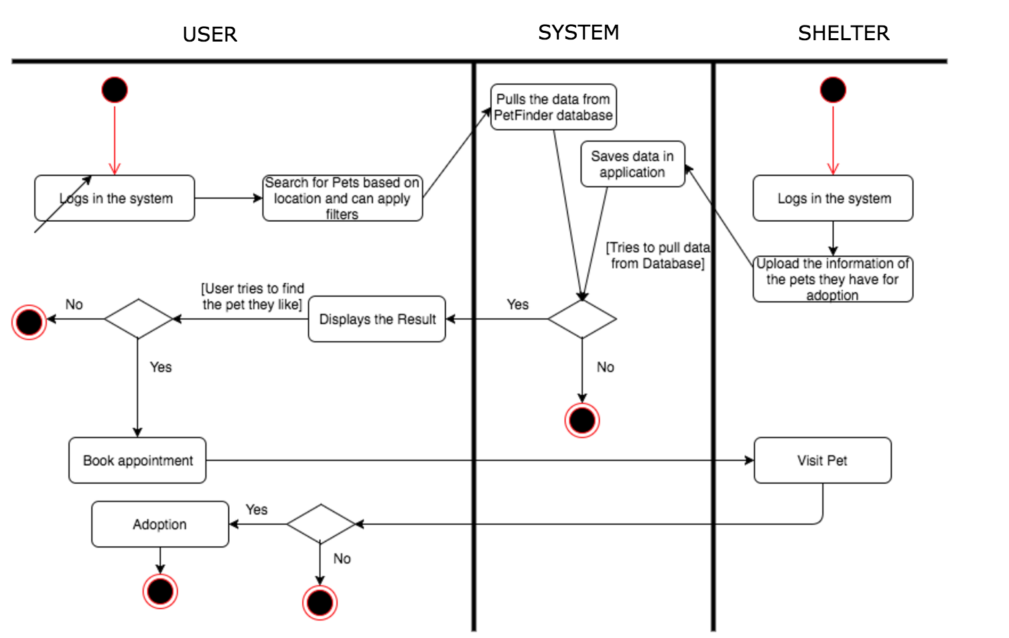**Figure 7: Business Workflow Diagram of Mobile application**

The Figure 7 gives the basic flow of function in the system with the line of transaction. Geographical mapping of location to search based on proximity of the user and the expansion of the system to the shelter module is the roadmap.

#### Organizational and Operational Implications

##### Organizational Transformations

The need to hire a new system maintainer with knowledge on mobile application development. He will also be responsible for the google location services integration and should be able to work hand in hand with the existing backend system administrator to synchronize the work with the web application.

##### Operational Transformations

The mobile application is a closed system and hence one cannot just browse through the application to find details regarding pets and the shelters. This strategy is established for if the business model is expanded in the future to generate revenue then the information regarding the pets and the shelters become one of the primary stakeholders.